PIZZA SALES SQL QUERIES

A:KPI

1: Total REVENUE

SELECT SUM(total_price)AS Total_Revenue from pizza_sales

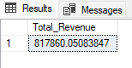

2:Total pizza soled

SELECT SUM(quantity)as Total_pizza_sold from pizza_sales

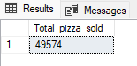

3:Avg_order_Value

SELECT SUM(total_price) /COUNT(DISTINCT order_id)as Avg_orde_value from pizza_sales

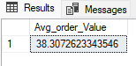

4:Total_Order

SELECT COUNT(DISTINCT order_id)as total_order from pizza_sales

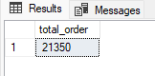

5: PIZZA_PER_OREDR

SELECT CAST (CAST(SUM(quantity) AS DECIMAL(10,2)) /

CAST(COUNT(DISTINCT order_id) AS DECIMAL (10,2)) AS DECIMAL(10,2))AS PIZZA_PER_OREDR from pizza_sales

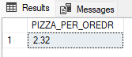

6:DAILY_TREAD_WEEK

SELECT DATENAME(DW, order_date) as order_day, COUNT(DISTINCT order_id) as Total_order from pizza_sales

GROUP BY DATENAME(DW, order_date)

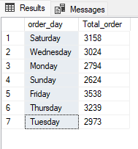

7: Total_tred_in month Frome Largest to Lowest

SELECT DATENAME(MONTH, order_date) as Month_Name, COUNT(DISTINCT order_id) as Total_Orders

FROM pizza_sales

GROUP BY DATENAME(MONTH, order_date)

ORDER BY Total_Orders DESC

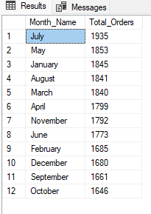

8: PERCENTAGE_OF_Total_pizza_sels

SELECT pizza_category,sum(total_price) * 100 /(SELECT sum(total_price) from pizza_sales)AS PCT

FROM pizza_sales

GROUP BY pizza_category

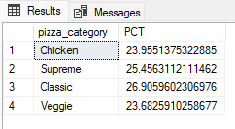

NOTE

If you want to apply the Month ,Quarter,Week filers to above queries you can use WHERE clause. Follow some of below example

SELECT pizza_category,sum(total_price) as total_sales, sum(total_price) * 100 /(SELECT sum(total_price) from pizza_sales)AS PCT

FROM pizza_sales

WHERE MONTH(order_date) = 1

GROUP BY pizza_category

*HERE MONTH(order_date = 1 indicates that the output is for the month of januaey.month(order_date) = 4 indicates output for month of April

SELECT DATENAME(DW,order_date) as order_day,COUNT(DISTINCT order_id) AS total_orders

FROM pizza_sales

WHERE DATEPART(QUARTER,order_date) =1

GROUP BY DATENAME(DW,order_date)

8: PERCENTAGE_Sales_by_pizza_category

SELECT pizza_category, sum(total_price) as Total_sales,sum(total_price) * 100 /

(SELECT SUM(total_price) from pizza_sales WHERE MONTH(order_date)=1) AS PCT

from pizza_sales

WHERE MONTH(order_date)=1

GROUP BY pizza_category

